**Cognizant Week-4_HandsOn**

Exercise-1: Create a Spring Web Project using Maven

Code:

**Ping Controller:**

package com.cognizant.springlearn.controller;  
  
import org.springframework.web.bind.annotation.GetMapping;  
import org.springframework.web.bind.annotation.RequestMapping;  
import org.springframework.web.bind.annotation.RestController;  
  
@RestController  
@RequestMapping("/")  
public class PingController {  
  
 @GetMapping  
 public String hello() {  
 return "Hello, Spring!";  
 }  
}

**Spring Learn Application:**

package com.cognizant.springlearn;  
  
import org.springframework.boot.SpringApplication;  
import org.springframework.boot.autoconfigure.SpringBootApplication;  
  
@SpringBootApplication  
public class SpringLearnApplication {  
  
 public static void main(String[] args) {  
 SpringApplication.*run*(SpringLearnApplication.class, args);  
 }  
}

**Test Class**:

package com.cognizant.springlearn;  
  
import org.junit.jupiter.api.Test;  
import org.springframework.boot.test.context.SpringBootTest;  
  
@SpringBootTest  
class SpringLearnApplicationTests {  
  
 @Test  
 void contextLoads() {  
 }  
  
}

**Pom.xml:**

<project xmlns="http://maven.apache.org/POM/4.0.0"  
 xmlns:xsi="http://www.w3.org/2001/XMLSchema-instance"  
 xsi:schemaLocation="http://maven.apache.org/POM/4.0.0 https://maven.apache.org/xsd/maven-4.0.0.xsd">  
 <modelVersion>4.0.0</modelVersion>  
  
 <parent>  
 <groupId>org.springframework.boot</groupId>  
 <artifactId>spring-boot-starter-parent</artifactId>  
 <version>3.3.1</version>  
 <relativePath/> <!-- lookup parent from repository -->  
 </parent>  
  
 <groupId>com.cognizant</groupId>  
 <artifactId>spring-learn</artifactId>  
 <version>0.0.1-SNAPSHOT</version>  
 <name>spring-learn</name>  
 <description>Demo Spring Web project</description>  
 <packaging>jar</packaging>  
  
 <properties>  
 <java.version>21</java.version>  
 </properties>  
  
 <dependencies>  
 <dependency>  
 <groupId>org.springframework.boot</groupId>  
 <artifactId>spring-boot-starter-web</artifactId>  
 </dependency>  
  
 <dependency>  
 <groupId>org.springframework.boot</groupId>  
 <artifactId>spring-boot-devtools</artifactId>  
 <scope>runtime</scope>  
 <optional>true</optional>  
 </dependency>  
  
 <dependency>  
 <groupId>org.springframework.boot</groupId>  
 <artifactId>spring-boot-starter-test</artifactId>  
 <scope>test</scope>  
 </dependency>  
 </dependencies>  
  
 <build>  
 <plugins>  
 <plugin>  
 <groupId>org.springframework.boot</groupId>  
 <artifactId>spring-boot-maven-plugin</artifactId>  
 </plugin>  
 </plugins>  
 </build>  
  
</project>

**Output:**

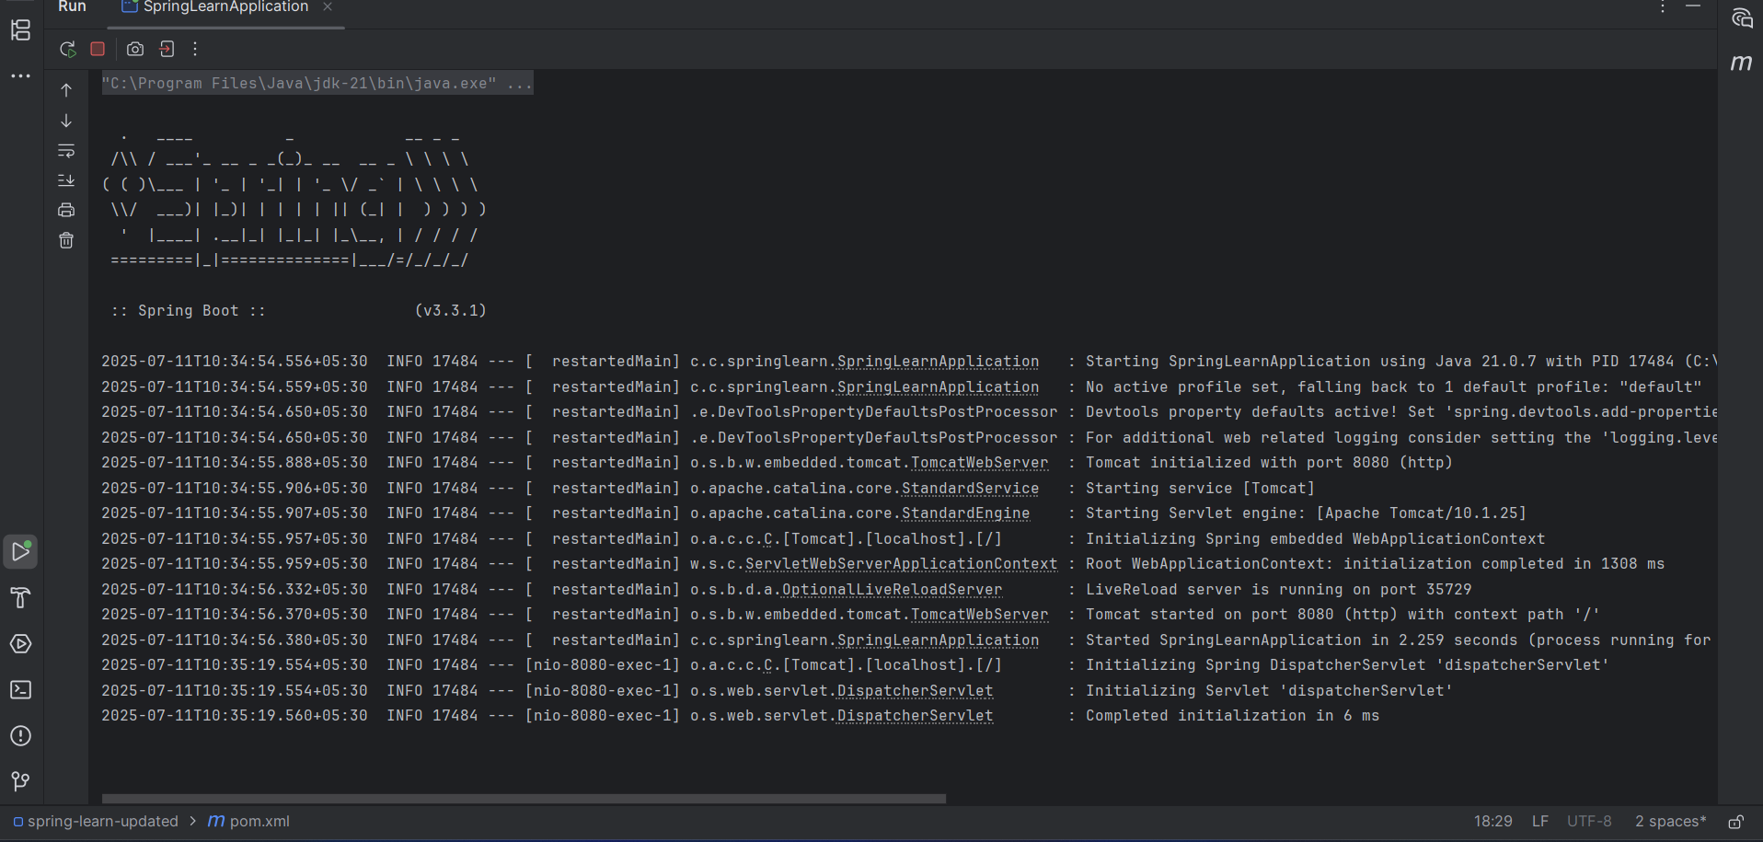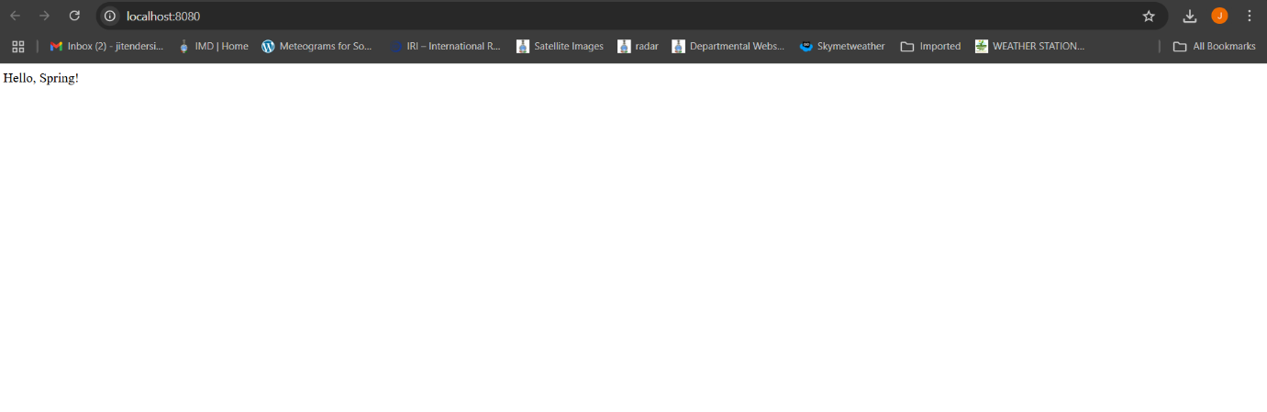

**Exercise: Spring Core – Load Country from Spring Configuration XML**

**Code:**

**PingController.java:**

package com.cognizant.springlearn.controller;  
  
import org.springframework.web.bind.annotation.GetMapping;  
import org.springframework.web.bind.annotation.RequestMapping;  
import org.springframework.web.bind.annotation.RestController;  
  
@RestController  
@RequestMapping("/")  
public class PingController {  
  
 @GetMapping  
 public String hello() {  
 return "Hello, Spring!";  
 }  
}

**Country.java**:

package com.cognizant.springlearn;  
  
import org.slf4j.Logger;  
import org.slf4j.LoggerFactory;  
  
public class Country {  
  
 private static final Logger *LOGGER* = LoggerFactory.*getLogger*(Country.class);  
  
 private String code;  
 private String name;  
  
 public Country() {  
 *LOGGER*.debug("Inside Country Constructor.");  
 }  
  
 public String getCode() {  
 *LOGGER*.debug("Inside getCode");  
 return code;  
 }  
  
 public void setCode(String code) {  
 *LOGGER*.debug("Inside setCode");  
 this.code = code;  
 }  
  
 public String getName() {  
 *LOGGER*.debug("Inside getName");  
 return name;  
 }  
  
 public void setName(String name) {  
 *LOGGER*.debug("Inside setName");  
 this.name = name;  
 }  
  
 @Override  
 public String toString() {  
 return "Country [code=" + code + ", name=" + name + "]";  
 }  
}

**SpringLearnApplication.java:**

package com.cognizant.springlearn;  
  
import org.slf4j.Logger;  
import org.slf4j.LoggerFactory;  
import org.springframework.boot.SpringApplication;  
import org.springframework.boot.autoconfigure.SpringBootApplication;  
import org.springframework.context.ApplicationContext;  
import org.springframework.context.support.ClassPathXmlApplicationContext;  
  
@SpringBootApplication  
public class SpringLearnApplication {  
  
 private static final Logger *LOGGER* = LoggerFactory.*getLogger*(SpringLearnApplication.class);  
  
 public static void main(String[] args) {  
 SpringApplication.*run*(SpringLearnApplication.class, args);  
 *displayCountry*();  
 }  
  
 public static void displayCountry() {  
 ApplicationContext context = new ClassPathXmlApplicationContext("country.xml");  
 Country country = (Country) context.getBean("country", Country.class);  
 *LOGGER*.debug("Country : {}", country.toString());  
 }  
}

**Country.xml:**

<?xml version="1.0" encoding="UTF-8"?>  
<beans xmlns="http://www.springframework.org/schema/beans"  
 xmlns:xsi="http://www.w3.org/2001/XMLSchema-instance"  
 xsi:schemaLocation="http://www.springframework.org/schema/beans  
 https://www.springframework.org/schema/beans/spring-beans.xsd">  
  
 <bean id="country" class="com.cognizant.springlearn.Country">  
 <property name="code" value="IN"/>  
 <property name="name" value="India"/>  
 </bean>  
  
</beans>

**Test.java**:

package com.cognizant.springlearn;  
  
import org.junit.jupiter.api.Test;  
import org.springframework.boot.test.context.SpringBootTest;  
  
@SpringBootTest  
class SpringLearnApplicationTests {  
  
 @Test  
 void contextLoads() {  
 }  
  
}

**Output**:

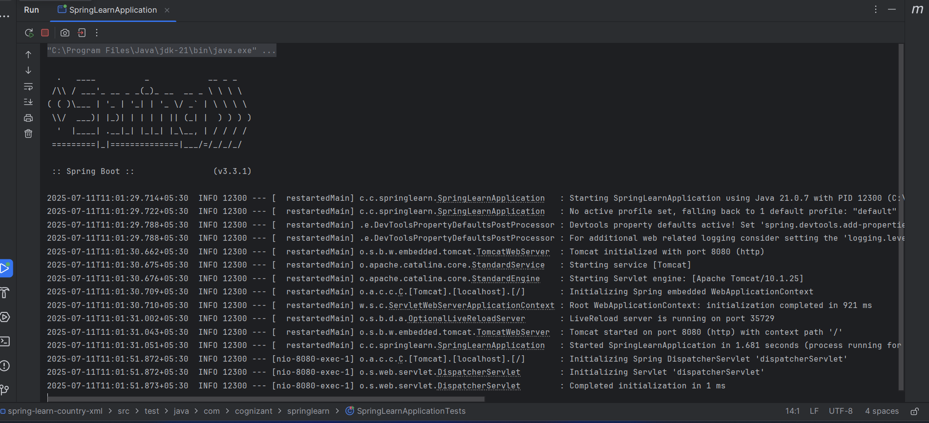

**Exercise: Hello World RESTful Web Service:**

**Code:**

**HelloController.java:**

package com.cognizant.springlearn.controller;  
  
import org.slf4j.Logger;  
import org.slf4j.LoggerFactory;  
import org.springframework.web.bind.annotation.GetMapping;  
import org.springframework.web.bind.annotation.RestController;  
  
@RestController  
public class HelloController {  
  
 private static final Logger *LOGGER* = LoggerFactory.*getLogger*(HelloController.class);  
  
 @GetMapping("/hello")  
 public String sayHello() {  
 *LOGGER*.info("START - /hello");  
 String msg = "Hello World!!";  
 *LOGGER*.info("END - /hello");  
 return msg;  
 }  
}

**Country.java:**

package com.cognizant.springlearn;  
  
import org.slf4j.Logger;  
import org.slf4j.LoggerFactory;  
  
public class Country {  
  
 private static final Logger *LOGGER* = LoggerFactory.*getLogger*(Country.class);  
  
 private String code;  
 private String name;  
  
 public Country() {  
 *LOGGER*.debug("Inside Country Constructor.");  
 }  
  
 public String getCode() {  
 *LOGGER*.debug("Inside getCode");  
 return code;  
 }  
  
 public void setCode(String code) {  
 *LOGGER*.debug("Inside setCode");  
 this.code = code;  
 }  
  
 public String getName() {  
 *LOGGER*.debug("Inside getName");  
 return name;  
 }  
  
 public void setName(String name) {  
 *LOGGER*.debug("Inside setName");  
 this.name = name;  
 }  
  
 @Override  
 public String toString() {  
 return "Country [code=" + code + ", name=" + name + "]";  
 }  
}

**SpringLearnApplication.java**:

package com.cognizant.springlearn;  
  
import org.slf4j.Logger;  
import org.slf4j.LoggerFactory;  
import org.springframework.boot.SpringApplication;  
import org.springframework.boot.autoconfigure.SpringBootApplication;  
import org.springframework.context.ApplicationContext;  
import org.springframework.context.support.ClassPathXmlApplicationContext;  
  
@SpringBootApplication  
public class SpringLearnApplication {  
  
 private static final Logger *LOGGER* = LoggerFactory.*getLogger*(SpringLearnApplication.class);  
  
 public static void main(String[] args) {  
 SpringApplication.*run*(SpringLearnApplication.class, args);  
 *displayCountry*();  
 }  
  
 public static void displayCountry() {  
 ApplicationContext context = new ClassPathXmlApplicationContext("country.xml");  
 Country country = (Country) context.getBean("country", Country.class);  
 *LOGGER*.debug("Country : {}", country.toString());  
 }  
}

**Country.xml**:

<?xml version="1.0" encoding="UTF-8"?>  
<beans xmlns="http://www.springframework.org/schema/beans"  
 xmlns:xsi="http://www.w3.org/2001/XMLSchema-instance"  
 xsi:schemaLocation="http://www.springframework.org/schema/beans  
 https://www.springframework.org/schema/beans/spring-beans.xsd">  
  
 <bean id="country" class="com.cognizant.springlearn.Country">  
 <property name="code" value="IN"/>  
 <property name="name" value="India"/>  
 </bean>  
  
</beans>

**Test.java**:

package com.cognizant.springlearn;  
  
import org.junit.jupiter.api.Test;  
import org.springframework.boot.test.context.SpringBootTest;  
  
@SpringBootTest  
class SpringLearnApplicationTests {  
  
 @Test  
 void contextLoads() {  
 }  
  
}

**Pom.xml**:

<project xmlns="http://maven.apache.org/POM/4.0.0"  
 xmlns:xsi="http://www.w3.org/2001/XMLSchema-instance"  
 xsi:schemaLocation="http://maven.apache.org/POM/4.0.0 https://maven.apache.org/xsd/maven-4.0.0.xsd">  
 <modelVersion>4.0.0</modelVersion>  
  
 <parent>  
 <groupId>org.springframework.boot</groupId>  
 <artifactId>spring-boot-starter-parent</artifactId>  
 <version>3.3.1</version>  
 <relativePath/> <!-- lookup parent from repository -->  
 </parent>  
  
 <groupId>com.cognizant</groupId>  
 <artifactId>spring-learn</artifactId>  
 <version>0.0.1-SNAPSHOT</version>  
 <name>spring-learn</name>  
 <description>Demo Spring Web project</description>  
 <packaging>jar</packaging>  
  
 <properties>  
 <java.version>21</java.version>  
 </properties>  
  
 <dependencies>  
 <dependency>  
 <groupId>org.springframework.boot</groupId>  
 <artifactId>spring-boot-starter-web</artifactId>  
 </dependency>  
  
 <dependency>  
 <groupId>org.springframework.boot</groupId>  
 <artifactId>spring-boot-devtools</artifactId>  
 <scope>runtime</scope>  
 <optional>true</optional>  
 </dependency>  
  
 <dependency>  
 <groupId>org.springframework.boot</groupId>  
 <artifactId>spring-boot-starter-test</artifactId>  
 <scope>test</scope>  
 </dependency>  
 </dependencies>  
  
 <build>  
 <plugins>  
 <plugin>  
 <groupId>org.springframework.boot</groupId>  
 <artifactId>spring-boot-maven-plugin</artifactId>  
 </plugin>  
 </plugins>  
 </build>  
  
</project>

**Output**:

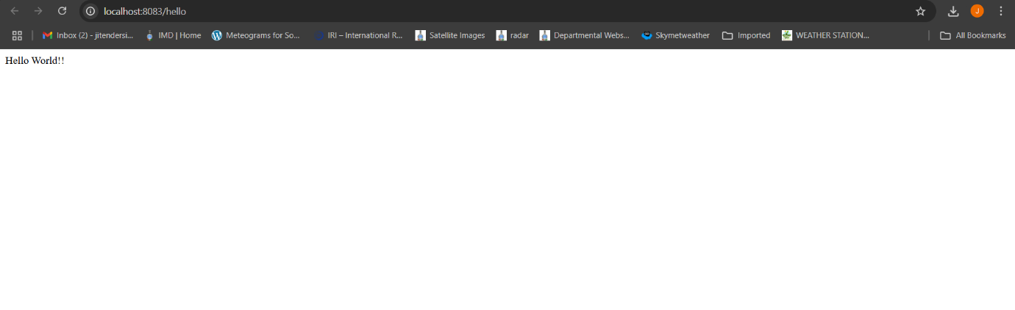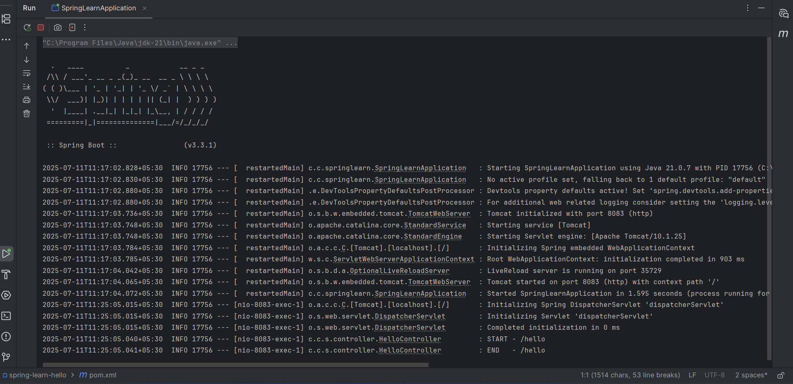

**Exercise: REST - Country Web Service**

**Code**:

**CountryController.java**:

package com.cognizant.springlearn.controller;  
  
import org.slf4j.Logger;  
import org.slf4j.LoggerFactory;  
import org.springframework.context.ApplicationContext;  
import org.springframework.context.support.ClassPathXmlApplicationContext;  
import org.springframework.web.bind.annotation.RequestMapping;  
import org.springframework.web.bind.annotation.RequestMethod;  
import org.springframework.web.bind.annotation.RestController;  
  
import com.cognizant.springlearn.Country;  
  
@RestController  
public class CountryController {  
  
 private static final Logger *LOGGER* = LoggerFactory.*getLogger*(CountryController.class);  
  
 @RequestMapping(value = "/country", method = RequestMethod.*GET*)  
 public Country getCountryIndia() {  
 *LOGGER*.info("START - /country");  
  
 // Load the XML configuration and retrieve the country bean  
 ApplicationContext context = new ClassPathXmlApplicationContext("country.xml");  
 Country india = context.getBean("country", Country.class);  
  
 *LOGGER*.info("END - /country");  
  
 return india; // Jackson converts this Country object to JSON  
 }  
}

**SpringLearnApplication.java**:

package com.cognizant.springlearn;  
  
import org.slf4j.Logger;  
import org.slf4j.LoggerFactory;  
import org.springframework.boot.SpringApplication;  
import org.springframework.boot.autoconfigure.SpringBootApplication;  
import org.springframework.context.ApplicationContext;  
import org.springframework.context.support.ClassPathXmlApplicationContext;  
  
@SpringBootApplication  
public class SpringLearnApplication {  
  
 private static final Logger *LOGGER* = LoggerFactory.*getLogger*(SpringLearnApplication.class);  
  
 public static void main(String[] args) {  
 SpringApplication.*run*(SpringLearnApplication.class, args);  
 *displayCountry*();  
 }  
  
 public static void displayCountry() {  
 ApplicationContext context = new ClassPathXmlApplicationContext("country.xml");  
 Country country = (Country) context.getBean("country", Country.class);  
 *LOGGER*.debug("Country : {}", country.toString());  
 }  
}

**Country.java:**

package com.cognizant.springlearn;  
  
import org.slf4j.Logger;  
import org.slf4j.LoggerFactory;  
  
public class Country {  
  
 private static final Logger *LOGGER* = LoggerFactory.*getLogger*(Country.class);  
  
 private String code;  
 private String name;  
  
 public Country() {  
 *LOGGER*.debug("Inside Country Constructor.");  
 }  
  
 public String getCode() {  
 *LOGGER*.debug("Inside getCode");  
 return code;  
 }  
  
 public void setCode(String code) {  
 *LOGGER*.debug("Inside setCode");  
 this.code = code;  
 }  
  
 public String getName() {  
 *LOGGER*.debug("Inside getName");  
 return name;  
 }  
  
 public void setName(String name) {  
 *LOGGER*.debug("Inside setName");  
 this.name = name;  
 }  
  
 @Override  
 public String toString() {  
 return "Country [code=" + code + ", name=" + name + "]";  
 }  
}

**Test.java**:

package com.cognizant.springlearn;  
  
import org.junit.jupiter.api.Test;  
import org.springframework.boot.test.context.SpringBootTest;  
  
@SpringBootTest  
class SpringLearnApplicationTests {  
  
 @Test  
 void contextLoads() {  
 }  
  
}

**Pom.xml:**

<project xmlns="http://maven.apache.org/POM/4.0.0"  
 xmlns:xsi="http://www.w3.org/2001/XMLSchema-instance"  
 xsi:schemaLocation="http://maven.apache.org/POM/4.0.0 https://maven.apache.org/xsd/maven-4.0.0.xsd">  
 <modelVersion>4.0.0</modelVersion>  
  
 <parent>  
 <groupId>org.springframework.boot</groupId>  
 <artifactId>spring-boot-starter-parent</artifactId>  
 <version>3.3.1</version>  
 <relativePath/> <!-- lookup parent from repository -->  
 </parent>  
  
 <groupId>com.cognizant</groupId>  
 <artifactId>spring-learn</artifactId>  
 <version>0.0.1-SNAPSHOT</version>  
 <name>spring-learn</name>  
 <description>Demo Spring Web project</description>  
 <packaging>jar</packaging>  
  
 <properties>  
 <java.version>21</java.version>  
 </properties>  
  
 <dependencies>  
 <dependency>  
 <groupId>org.springframework.boot</groupId>  
 <artifactId>spring-boot-starter-web</artifactId>  
 </dependency>  
  
 <dependency>  
 <groupId>org.springframework.boot</groupId>  
 <artifactId>spring-boot-devtools</artifactId>  
 <scope>runtime</scope>  
 <optional>true</optional>  
 </dependency>  
  
 <dependency>  
 <groupId>org.springframework.boot</groupId>  
 <artifactId>spring-boot-starter-test</artifactId>  
 <scope>test</scope>  
 </dependency>  
 </dependencies>  
  
 <build>  
 <plugins>  
 <plugin>  
 <groupId>org.springframework.boot</groupId>  
 <artifactId>spring-boot-maven-plugin</artifactId>  
 </plugin>  
 </plugins>  
 </build>  
  
</project>

**Output:**

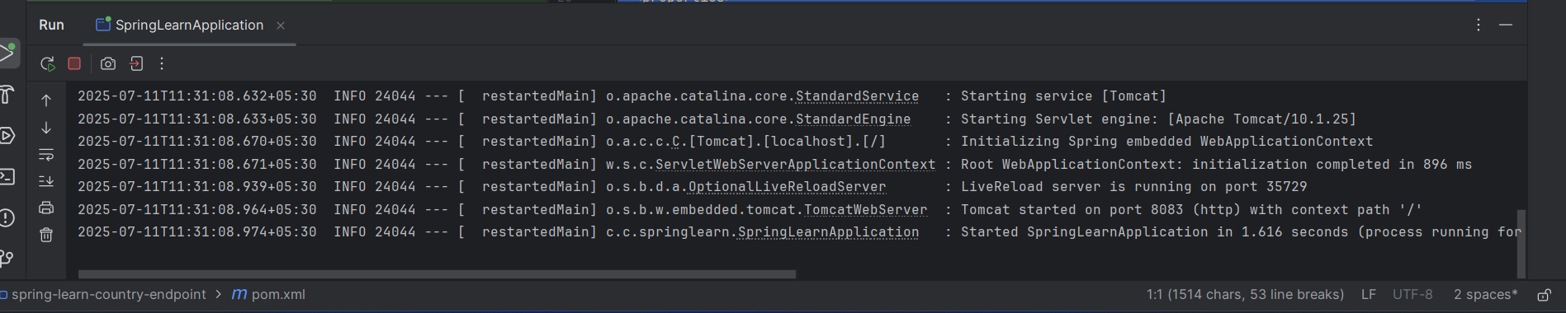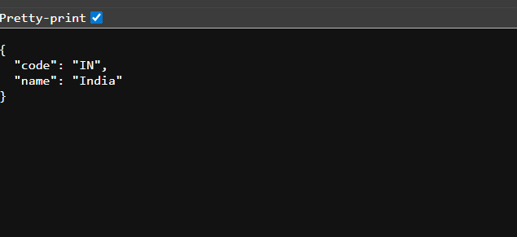

**Exercise: REST - Get country based on country code**

**Code**:

package com.cognizant.springlearn.controller;  
  
import com.cognizant.springlearn.service.CountryService;  
import org.slf4j.Logger;  
import org.slf4j.LoggerFactory;  
import org.springframework.context.ApplicationContext;  
import org.springframework.context.support.ClassPathXmlApplicationContext;  
import org.springframework.web.bind.annotation.PathVariable;  
import org.springframework.web.bind.annotation.RequestMapping;  
import org.springframework.web.bind.annotation.RequestMethod;  
import org.springframework.web.bind.annotation.RestController;  
  
import com.cognizant.springlearn.Country;  
  
import static CountryController.LOGGER;  
import static com.cognizant.springlearn.SpringLearnApplication.*LOGGER*;  
  
@RestController  
public class CountryController {  
  
 private static final Logger *LOGGER* = LoggerFactory.*getLogger*(CountryController.class);  
  
 @RequestMapping(value = "/country", method = RequestMethod.*GET*)  
 public Country getCountryIndia() {  
 *LOGGER*.info("START - /country");  
  
 // Load the XML configuration and retrieve the country bean  
 ApplicationContext context = new ClassPathXmlApplicationContext("country.xml");  
 Country india = context.getBean("country", Country.class);  
  
 *LOGGER*.info("END - /country");  
  
 return india; // Jackson converts this Country object to JSON  
 }  
}  
  
@RequestMapping(value = "/countries/{code}", method = RequestMethod.*GET*)  
public Country getCountry(@PathVariable String code) {  
 *LOGGER*.info("START - /countries/{}", code);  
 CountryService service = new CountryService();  
 Country country = service.getCountry(code);  
 *LOGGER*.info("END - /countries/{}", code);  
 return country;  
}

**CountryService.java**:

package com.cognizant.springlearn.service;  
  
import com.cognizant.springlearn.Country;  
import org.springframework.context.ApplicationContext;  
import org.springframework.context.support.ClassPathXmlApplicationContext;  
import org.springframework.stereotype.Service;  
  
import java.util.List;  
  
@Service  
public class CountryService {  
  
 public Country getCountry(String code) {  
 ApplicationContext context = new ClassPathXmlApplicationContext("country.xml");  
 List<Country> countryList = context.getBean("countryList", List.class);  
 return countryList.stream()  
 .filter(country -> country.getCode().equalsIgnoreCase(code))  
 .findFirst()  
 .orElse(null);  
 }  
}

**Country.java:**

package com.cognizant.springlearn;  
  
import org.slf4j.Logger;  
import org.slf4j.LoggerFactory;  
  
public class Country {  
  
 private static final Logger *LOGGER* = LoggerFactory.*getLogger*(Country.class);  
  
 private String code;  
 private String name;  
  
 public Country() {  
 *LOGGER*.debug("Inside Country Constructor.");  
 }  
  
 public String getCode() {  
 *LOGGER*.debug("Inside getCode");  
 return code;  
 }  
  
 public void setCode(String code) {  
 *LOGGER*.debug("Inside setCode");  
 this.code = code;  
 }  
  
 public String getName() {  
 *LOGGER*.debug("Inside getName");  
 return name;  
 }  
  
 public void setName(String name) {  
 *LOGGER*.debug("Inside setName");  
 this.name = name;  
 }  
  
 @Override  
 public String toString() {  
 return "Country [code=" + code + ", name=" + name + "]";  
 }  
}

package com.cognizant.springlearn;  
  
import org.slf4j.Logger;  
import org.slf4j.LoggerFactory;  
import org.springframework.boot.SpringApplication;  
import org.springframework.boot.autoconfigure.SpringBootApplication;  
import org.springframework.context.ApplicationContext;  
import org.springframework.context.support.ClassPathXmlApplicationContext;  
  
@SpringBootApplication  
public class SpringLearnApplication {  
  
 private static final Logger *LOGGER* = LoggerFactory.*getLogger*(SpringLearnApplication.class);  
  
 public static void main(String[] args) {  
 SpringApplication.*run*(SpringLearnApplication.class, args);  
 *displayCountry*();  
 }  
  
 public static void displayCountry() {  
 ApplicationContext context = new ClassPathXmlApplicationContext("country.xml");  
 Country country = (Country) context.getBean("country", Country.class);  
 *LOGGER*.debug("Country : {}", country.toString());  
 }  
}

**Test.java**:

package com.cognizant.springlearn;  
  
import org.junit.jupiter.api.Test;  
import org.springframework.boot.test.context.SpringBootTest;  
  
@SpringBootTest  
class SpringLearnApplicationTests {  
  
 @Test  
 void contextLoads() {  
 }  
  
}

**Pom.xml**:

<project xmlns="http://maven.apache.org/POM/4.0.0"  
 xmlns:xsi="http://www.w3.org/2001/XMLSchema-instance"  
 xsi:schemaLocation="http://maven.apache.org/POM/4.0.0 https://maven.apache.org/xsd/maven-4.0.0.xsd">  
 <modelVersion>4.0.0</modelVersion>  
  
 <parent>  
 <groupId>org.springframework.boot</groupId>  
 <artifactId>spring-boot-starter-parent</artifactId>  
 <version>3.3.1</version>  
 <relativePath/> <!-- lookup parent from repository -->  
 </parent>  
  
 <groupId>com.cognizant</groupId>  
 <artifactId>spring-learn</artifactId>  
 <version>0.0.1-SNAPSHOT</version>  
 <name>spring-learn</name>  
 <description>Demo Spring Web project</description>  
 <packaging>jar</packaging>  
  
 <properties>  
 <java.version>21</java.version>  
 </properties>  
  
 <dependencies>  
 <dependency>  
 <groupId>org.springframework.boot</groupId>  
 <artifactId>spring-boot-starter-web</artifactId>  
 </dependency>  
  
 <dependency>  
 <groupId>org.springframework.boot</groupId>  
 <artifactId>spring-boot-devtools</artifactId>  
 <scope>runtime</scope>  
 <optional>true</optional>  
 </dependency>  
  
 <dependency>  
 <groupId>org.springframework.boot</groupId>  
 <artifactId>spring-boot-starter-test</artifactId>  
 <scope>test</scope>  
 </dependency>  
 </dependencies>  
  
 <build>  
 <plugins>  
 <plugin>  
 <groupId>org.springframework.boot</groupId>  
 <artifactId>spring-boot-maven-plugin</artifactId>  
 </plugin>  
 </plugins>  
 </build>  
  
</project>

**Exercise: Create authentication service that returns JWT**

**Code:**

package com.cognizant.springlearn.config;  
  
import org.springframework.context.annotation.Bean;  
import org.springframework.context.annotation.Configuration;  
import org.springframework.security.config.Customizer;  
import org.springframework.security.config.annotation.web.builders.HttpSecurity;  
import org.springframework.security.core.userdetails.User;  
import org.springframework.security.core.userdetails.UserDetails;  
import org.springframework.security.core.userdetails.UserDetailsService;  
import org.springframework.security.crypto.bcrypt.BCryptPasswordEncoder;  
import org.springframework.security.crypto.password.PasswordEncoder;  
import org.springframework.security.provisioning.InMemoryUserDetailsManager;  
import org.springframework.security.web.SecurityFilterChain;  
  
@Configuration  
public class SecurityConfig {  
  
 @Bean  
 public PasswordEncoder passwordEncoder() {  
 return new BCryptPasswordEncoder();  
 }  
  
 @Bean  
 public UserDetailsService users(PasswordEncoder encoder) {  
 UserDetails user = User.builder()  
 .username("user")  
 .password(encoder.encode("pwd"))  
 .roles("USER")  
 .build();  
 return new InMemoryUserDetailsManager(user);  
 }  
  
 @Bean  
 public SecurityFilterChain filterChain(HttpSecurity http) throws Exception {  
 http.csrf(csrf -> csrf.disable())  
 .authorizeHttpRequests(auth -> auth  
 .requestMatchers("/authenticate").authenticated()  
 .anyRequest().permitAll())  
 .httpBasic(Customizer.withDefaults());  
 return http.build();  
 }  
}

package com.cognizant.springlearn.controller;  
  
import java.util.HashMap;  
import java.util.Map;  
  
import org.slf4j.Logger;  
import org.slf4j.LoggerFactory;  
import org.springframework.security.core.Authentication;  
import org.springframework.web.bind.annotation.GetMapping;  
import org.springframework.web.bind.annotation.RestController;  
  
import com.cognizant.springlearn.util.JwtUtil;  
  
@RestController  
public class AuthenticationController {  
  
 private static final Logger *LOGGER* = LoggerFactory.getLogger(AuthenticationController.class);  
  
 private final JwtUtil jwtUtil;  
  
 public AuthenticationController(JwtUtil jwtUtil) {  
 this.jwtUtil = jwtUtil;  
 }  
  
 @GetMapping("/authenticate")  
 public Map<String, String> authenticate(Authentication authentication) {  
 *LOGGER*.info("START - /authenticate for user {}", authentication.getName());  
 String token = jwtUtil.generateToken(authentication.getName());  
 *LOGGER*.info("END - /authenticate");  
 Map<String, String> response = new HashMap<>();  
 response.put("token", token);  
 return response;  
 }  
}

package com.cognizant.springlearn.controller;  
  
import org.slf4j.Logger;  
import org.slf4j.LoggerFactory;  
import org.springframework.context.ApplicationContext;  
import org.springframework.context.support.ClassPathXmlApplicationContext;  
import org.springframework.web.bind.annotation.RequestMapping;  
import org.springframework.web.bind.annotation.RequestMethod;  
import org.springframework.web.bind.annotation.RestController;  
  
import com.cognizant.springlearn.Country;  
  
@RestController  
public class CountryController {  
  
 private static final Logger *LOGGER* = LoggerFactory.getLogger(CountryController.class);  
  
 @RequestMapping(value = "/country", method = RequestMethod.GET)  
 public Country getCountryIndia() {  
 *LOGGER*.info("START - /country");  
  
 // Load the XML configuration and retrieve the country bean  
 ApplicationContext context = new ClassPathXmlApplicationContext("country.xml");  
 Country india = context.getBean("country", Country.class);  
  
 *LOGGER*.info("END - /country");  
  
 return india; // Jackson converts this Country object to JSON  
 }  
}  
  
@RequestMapping(value = "/countries/{code}", method = RequestMethod.GET)  
public Country getCountry(@PathVariable String code) {  
 LOGGER.info("START - /countries/{}", code);  
 CountryService service = new CountryService();  
 Country country = service.getCountry(code);  
 LOGGER.info("END - /countries/{}", code);  
 return country;  
}

package com.cognizant.springlearn.service;  
  
import com.cognizant.springlearn.Country;  
import org.springframework.context.ApplicationContext;  
import org.springframework.context.support.ClassPathXmlApplicationContext;  
import org.springframework.stereotype.Service;  
  
import java.util.List;  
  
@com.cognizant.springlearn.service.Service  
public class CountryService {  
  
 public Country getCountry(String code) {  
 ApplicationContext context = new ClassPathXmlApplicationContext("country.xml");  
 List<Country> countryList = context.getBean("countryList", List.class);  
 return countryList.stream()  
 .filter(country -> country.getCode().equalsIgnoreCase(code))  
 .findFirst()  
 .orElse(null);  
 }  
}

package com.cognizant.springlearn;  
  
import org.slf4j.Logger;  
import org.slf4j.LoggerFactory;  
import org.springframework.boot.SpringApplication;  
import org.springframework.boot.autoconfigure.SpringBootApplication;  
import org.springframework.context.ApplicationContext;  
import org.springframework.context.support.ClassPathXmlApplicationContext;  
  
@SpringBootApplication  
public class SpringLearnApplication {  
  
 private static final Logger *LOGGER* = LoggerFactory.getLogger(SpringLearnApplication.class);  
  
 public static void main(String[] args) {  
 SpringApplication.run(SpringLearnApplication.class, args);  
 *displayCountry*();  
 }  
  
 public static void displayCountry() {  
 ApplicationContext context = new ClassPathXmlApplicationContext("country.xml");  
 Country country = (Country) context.getBean("country", Country.class);  
 *LOGGER*.debug("Country : {}", country.toString());  
 }  
}

**Pom.xml**:

<ns0:project xmlns:ns0="http://maven.apache.org/POM/4.0.0" xmlns:xsi="http://www.w3.org/2001/XMLSchema-instance" xsi:schemaLocation="http://maven.apache.org/POM/4.0.0 https://maven.apache.org/xsd/maven-4.0.0.xsd">  
 <ns0:modelVersion>4.0.0</ns0:modelVersion>  
 <ns0:parent>  
 <ns0:groupId>org.springframework.boot</ns0:groupId>  
 <ns0:artifactId>spring-boot-starter-parent</ns0:artifactId>  
 <ns0:version>3.3.1</ns0:version>  
 <ns0:relativePath />  
 </ns0:parent>  
 <ns0:groupId>com.cognizant</ns0:groupId>  
 <ns0:artifactId>spring-learn</ns0:artifactId>  
 <ns0:version>0.0.1-SNAPSHOT</ns0:version>  
 <ns0:name>spring-learn</ns0:name>  
 <ns0:description>Demo Spring Web project</ns0:description>  
 <ns0:packaging>jar</ns0:packaging>  
 <ns0:properties>  
 <ns0:java.version>21</ns0:java.version>  
 </ns0:properties>  
 <ns0:dependencies>  
 <ns0:dependency>  
 <ns0:groupId>org.springframework.boot</ns0:groupId>  
 <ns0:artifactId>spring-boot-starter-web</ns0:artifactId>  
 </ns0:dependency>  
 <ns0:dependency>  
 <ns0:groupId>org.springframework.boot</ns0:groupId>  
 <ns0:artifactId>spring-boot-devtools</ns0:artifactId>  
 <ns0:scope>runtime</ns0:scope>  
 <ns0:optional>true</ns0:optional>  
 </ns0:dependency>  
 <ns0:dependency>  
 <ns0:groupId>org.springframework.boot</ns0:groupId>  
 <ns0:artifactId>spring-boot-starter-test</ns0:artifactId>  
 <ns0:scope>test</ns0:scope>  
 </ns0:dependency>  
 <dependency>  
 <groupId>org.springframework.boot</groupId>  
 <artifactId>spring-boot-starter-security</artifactId>  
 </dependency>  
 <dependency>  
 <groupId>io.jsonwebtoken</groupId>  
 <artifactId>jjwt</artifactId>  
 <version>0.9.1</version>  
 </dependency>  
 </ns0:dependencies>  
 <ns0:build>  
 <ns0:plugins>  
 <ns0:plugin>  
 <ns0:groupId>org.springframework.boot</ns0:groupId>  
 <ns0:artifactId>spring-boot-maven-plugin</ns0:artifactId>  
 </ns0:plugin>  
 </ns0:plugins>  
 </ns0:build>  
</ns0:project>